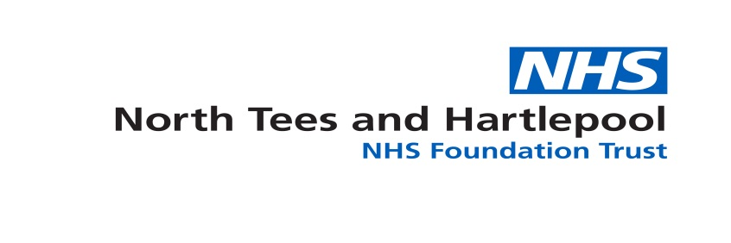
Expression of Interest
RSPH Level 3 Diploma APT Top up Programme
North Tees & Hartlepool NHS FT is a registered centre for the qualification – Level 3 Diploma in Anatomical Pathology Technology (APT) – centre number 4521.
We are delighted to announce dates this year for the level 3 diploma APT top up programme for APTs who currently hold the previous RSPH certificate & diploma examinations in APT and who wish to progress to current RSPH level 4 diploma qualification and beyond.
The programme will consist of the following level 3 modules and will require the following assessments:
Unit Number: | Title: | Assessment Method:
Unit APT 3.1 | Human anatomy and physiology for anatomical pathology technologists | CPD portfolio evidence
Unit APT 3.2 | Governance and administration of mortuary practices | CPD portfolio evidence
Unit APT 3.3 | Health and safety in the mortuary | CPD portfolio evidence
Unit APT 3.4 | Microbiology and infection control for anatomical pathology technologists | 1 x exam – microbiology  1 x assignment – infection control
Unit APT 3.5 | Principles of effective communication for anatomical pathology technologists | 1 x assignment
Unit APT 3.6A | Assist with post mortem examinations | CPD portfolio evidence
Unit APT 3.7 | Preparation and operation of a mortuary | CPD portfolio evidence
Unit APT 3.8 | Prepare for post mortem examinations | CPD portfolio evidence
Unit APT 3.9 | Team working | CPD portfolio evidence
Unit APT 3.11 | Viewing of the deceased | CPD portfolio evidence

The programme will start with distance learning materials and support being emailed to students and a distance learning support student group being set up on a social media platform.
The intensive in house programme will be for 2 and half days over a weekend period to support students being able to attend most of the course outside of mortuary working hours – the dates for the programme are: 24th / 25th / 26th of June.
Saturday 24th June 11am – 5pm
Sunday 25th June 10am – 4pm
Monday 26th June 9am – 12pm
The examination for the microbiology component will be scheduled for the first week of September as part of a one day hand in of assignments and portfolio evidence – date to be announced once expressions of interest have been submitted and processed.
The cost of the programme is £650.00 which includes the £250.00 RSPH fee for participation. It may be possible to pay for the programme in 2 / 3 instalments if required.
You will be required to send copies of your certificate & diploma qualifications in advance of starting the course – if you do not hold copies of your certificates, an RSPH check will be completed.
Once the programme is complete and all modules passed successfully you will receive a certificate from North Tees & Hartlepool NHS FT stating you have demonstrated learning in all required elements comparable to the level 3 diploma APT which can be presented to level 4 APT providers for admittance to the level 4 qualification.
If you are interested in the programme please complete the following fields and return your completed form to MortuaryTraining@nth.nhs.uk no later than May 19th 2017.
Name: |  | Employing Organisation: | Post Title:
Email Address:
I can confirm I hold RSPH the certificate & diploma in anatomical pathology technology:
Signed: |  |  | Date:

Once received a short formal application and learning agreement will be sent with an invoice proforma to be completed and returned.
If you are unable to attend these dates but would be interested in attending later in the year / next year please complete the following and send back:
Name:
Email:

We will then keep your information on file and contact at a later date:
We look forward to hearing from you!

