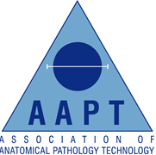
MARCH 2019 COUNCIL ACTIVITY

March is a quieter month of the year for Council although we are always up to something.

Lydia has been AHCS (Academy of Health Care Science) assessing and identified that the Best Practice Document needs to be updated, along with liaising with students.
Ishbel busy dealing with PR emails and press questions and the Health Education Summit with HEE.
John attended and live tweeted the Chief Scientific Officers Conference and has been trialling video conference software with Ishbel, Tarot, Alison and Emma.
Debbie continuing with the upkeep of the AAPT accounts along with being in touch with potential venues for the 2020 Annual Education Event.
Tarot preparing information from HTA inspections to share good practice and raise awareness. Liaising with the about the upcoming meeting in May National Bereavement Association
Alison sharing interesting articles and news via the APT Facebook page and twitter.
Gemma (student rep) dealing with more queries about the APT career and working on ways to reach out and support current students.
Sarah continual working through HTA reports finding good practice.
Emma working with Debbie, Lydia and Christian on the Annual Education Event, recruiting new APT members.

