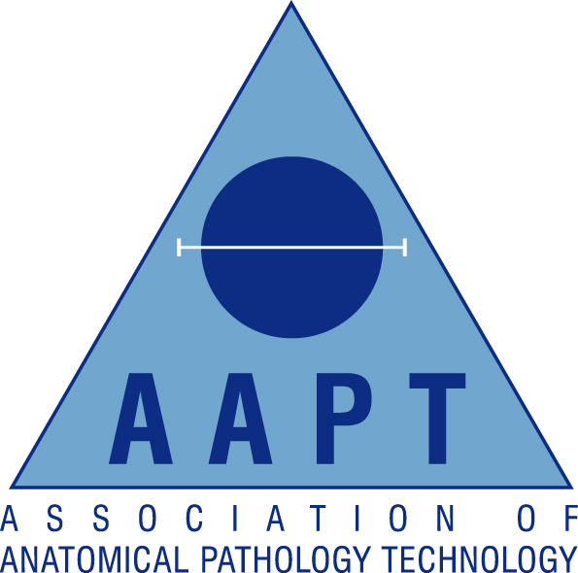

London & South East Regional AAPT Network

Lecture evening

Thursday 27th June 2019
Organised by Lara-Rose Iredale
Return form to: lara-rose.iredale@gstt.nhs.uk or fax 0207 188 3927

Location: The Gordon Museum of Pathology, Hodgkin Building, Guy’s Campus, King’s College London, London, SE1 1UL More detailed directions (complete with photos) to follow.
Website: https://www.kcl.ac.uk/gordon
The Museum will be accessible to browse before the event should you wish to arrive earlier than 6pm. Please note that the Gordon Museum is not open to members of the general public and that all visitors will need to bring some relevant Professional ID with them. Also to be aware that all forms of Photography, Filming and Social Media are prohibited whilst in the Gordon Museum.
18.00-18.30 Registration

18.30-19.30 “The Management of Mass Fatalities Incidents- the Coroner’s perspective”- Professor Fiona Jane Wilcox, Her Majesty's Senior Coroner for London (Inner West)

19:30-20:00 Q&A followed by collection of CPD certificates and close

AAPT Membership Number:

Non-Member (please tick)

Personal Details:

Surname |  | Title:  (Mr/Mrs/Miss/Ms)
Forenames

Contact Details:

Contact Address

Town/City |  | Postcode
Email |  | Contact Tel

