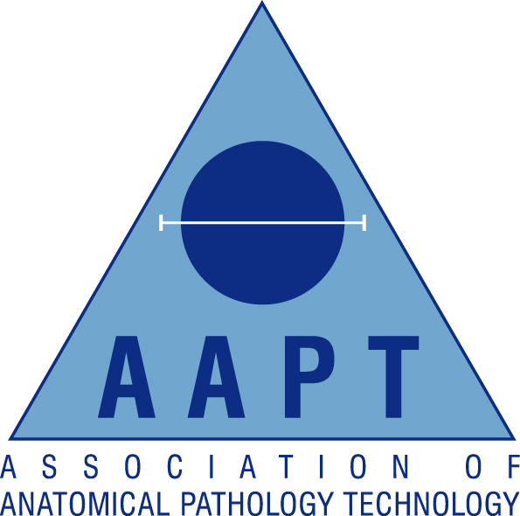

London & South East Regional AAPT Network

Lecture evening

Friday 11th October 2013

Return form to Network Lead TRACEY BIGGS via email Tracey.Biggs@gstt.nhs.uk

Location:
The Gordon Museum, Kings College London, Guy’s Campus SE1
18.00 Registration
18.45-1915 Maternal Deaths Professor Sebastian Lucas
19.15-19.30 Q&A followed by a break
19.30-20.00 CBRN post mortem examinations Zoe Rutherford MAAPT
20.00-20.15 Q&A followed by collection of CPD Certificates and close

AAPT Membership Number:

Non-Member (please tick)

Personal Details:

Surname |  | Title:  (Mr/Mrs/Miss/Ms)
Forenames

Contact Details:

Contact Address

Town/City |  | Postcode
Email |  | Contact Tel

