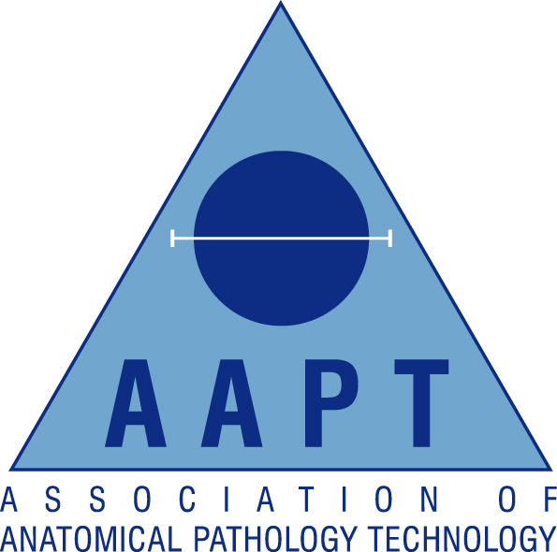

London & South East Regional AAPT Network

Lecture evening

Friday 5th August 2016
Organised by Steve Burr & Francesca Benson
Return form to: steven.burr@nhs.net or fax 01843 234471
Location: Lecture Theatre, Queen Elizabeth, The Queen Mother Hospital, St Peters Road, Margate, CT1 4AN
http://www.ekhuft.nhs.uk/patients-and-visitors/queen-elizabeth-the-queen-mother-hospital/
Once at the hospital use the St Peters road entrance, turn left, follow the corridor to the Ramsgate Road entrance then take the right hand corridor for the Spencer Wing/Education centre

18.00-18.30 Registration
18.30-19.15 The Life of a Coroner
Richard Sturt, OBE, MSTJ, DCL, MA, FRSA Retired Coroner for the East Kent district
19.15-19.30 Q&A followed by a break
19.30-20.15 Open Wide! The Work of a Forensic Odontologist
Dr Jane Reece, Odontologist
20.15-20.30 Q&A followed by collection of CPD Certificates and close

AAPT Membership Number:

Non-Member (please tick)

Personal Details:

Surname |  | Title:  (Mr/Mrs/Miss/Ms)
Forenames

Contact Details:

Contact Address

Town/City |  | Postcode
Email |  | Contact Tel

