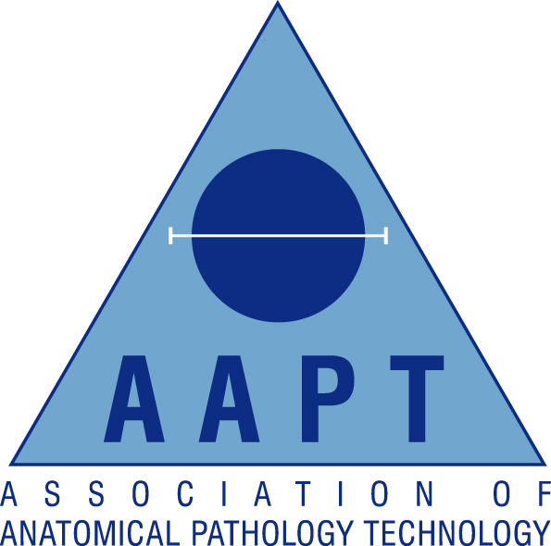

London & South East Regional AAPT Network

Lecture evening

Friday 5th February 2016
Organised by Lead: Lakiesha Ward & Co-Opted Trainee Jessica Saunders
Return form to: lakiesha.ward@gosh.nhs.uk or fax 0207 829 8674
Location: Histopathology Multi-Disciplinary Meeting Room,
4th Floor Bessemer Wing,
Kings College Hospital,
Denmark Hill
London SE5 9RS
18.00-18.30 Registration
18.30-19.00 Repatriation Funerals Without Frontiers
Steve Ryan – Mears Repatriation
19.00-19.15 Q&A followed by a break
19.15-20.15 Sudden Death Investigation & Blood Interpretation
Gareth Dineen – Complete Forensics
20.00-20.15 Collection of CPD Certificates and close

AAPT Membership Number:

Non-Member (please tick)

Personal Details:
Surname |  | Title:  (Mr/Mrs/Miss/Ms)
Forenames

Contact Details:
Contact Address

Town/City |  | Postcode
Email |  | Contact Tel

