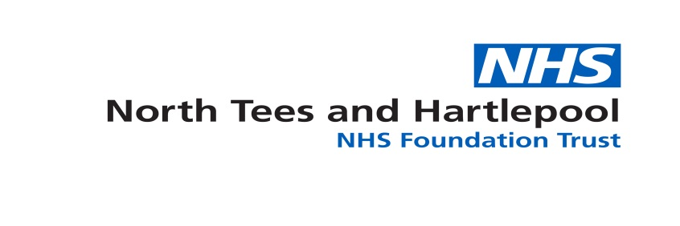
Expression of Interest
RSPH Level 3 Diploma APT Top up Programme
North Tees & Hartlepool NHS FT is a registered centre for the qualification – Level 3 Diploma in Anatomical Pathology Technology (APT) – centre number 4521.
We are delighted to announce the next dates for the level 3 diploma APT top up programme for APTs who currently hold the previous RSPH certificate & diploma examinations in APT and who wish to progress to current RSPH level 4 diploma qualification and beyond.
The programme will consist of the following level 3 modules and will require the following assessments:
Unit Number: | Title: | Assessment Method:
Unit APT 3.1 | Human anatomy and physiology for anatomical pathology technologists | CPD portfolio evidence
Unit APT 3.2 | Governance and administration of mortuary practices | CPD portfolio evidence
Unit APT 3.3 | Health and safety in the mortuary | CPD portfolio evidence
Unit APT 3.4 | Microbiology and infection control for anatomical pathology technologists | 1 x exam – microbiology  1 x assignment – infection control
Unit APT 3.5 | Principles of effective communication for anatomical pathology technologists | 1 x assignment
Unit APT 3.6A | Assist with post mortem examinations | CPD portfolio evidence
Unit APT 3.7 | Preparation and operation of a mortuary | CPD portfolio evidence
Unit APT 3.8 | Prepare for post mortem examinations | CPD portfolio evidence
Unit APT 3.9 | Team working | CPD portfolio evidence
Unit APT 3.11 | Viewing of the deceased | CPD portfolio evidence

The programme will start with distance learning materials and support being emailed to students and a distance learning support student group being set up on a social media platform.
The intensive in house programme will be for 2 days over a weekend period to support students being able to attend the course outside of mortuary working hours – the dates for the programme are:
Saturday 27th January 2018 10am – 5pm Course programme
Sunday 28th January 2018 10am – 4pm Course programme
Wednesday 18th July 2018 1pm – 5pm Hand in of assignments / portfolio
Thursday 19th July 2018 9am – 12pm Microbiology exam revision / exam
The 2 day weekend programme; 27th & 28th January 2018 will take place at Flax Bourton Public Mortuary in Bristol. The examination and portfolio hand in days are required by RSPH to be at the examination centre – University Hospital of North Tees, Stockton on Tees.
The examination for the microbiology component is scheduled for 19th July 2018 prior to a half day hand in of assignments and portfolio evidence on the 18th July.
The cost of the programme is £650.00 which includes the £250.00 RSPH fee for participation. It may be possible to pay for the programme in 2 / 3 instalments if required.
You will be required to send copies of your certificate & diploma qualifications in advance of starting the course – if you do not hold copies of your certificates, an RSPH check will be completed.
Once the programme is complete and all modules passed successfully you will receive a certificate from North Tees & Hartlepool NHS FT stating you have demonstrated learning in all required elements comparable to the level 3 diploma APT which can be presented to level 4 APT providers for admittance to the level 4 qualification.
If you are interested in the programme please complete the following fields and return your completed form to Michelle.lancaster@nth.nhs.uk no later than December 15th 2017
Name: |  | Employing Organisation: | Post Title:
Email Address:
I can confirm I hold RSPH the certificate & diploma in anatomical pathology technology:
Signed: |  |  | Date:

Once received a short formal application and learning agreement will be sent with an invoice proforma to be completed and returned.
If you are unable to attend these dates but would be interested in attending later in the year / next year please complete the following and send back:
Name:
Email:

We will then keep your information on file and contact at a later date.

