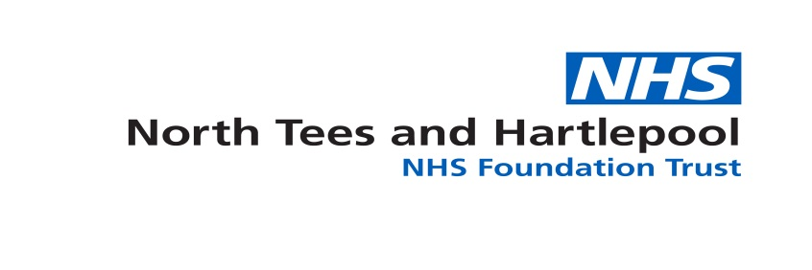

Expression of Interest
RSPH Level 4 Diploma - Anatomical Pathology Technology
North Tees & Hartlepool NHS FT is a registered centre for the qualification – Level 4 Diploma in Anatomical Pathology Technology (APT) – centre number 4521.
We are delighted to announce we now have RSPH accreditation to deliver the RSPH level 4 qualification – we are currently working on start dates for the programme which we are anticipating to commence from May 2018.
The programme will consist of the following modules
Unit Number: | Title:
APT 4.1 | Common human pathology for anatomical pathology technologists
APT 4.2 | Mortuary governance
APT 4.3 | Quality management in the mortuary
APT 4.4 | Advanced mortuary practice
APT 4.5 | Health and safety in the mortuary
APT 4.6 | Management of mortuary function
APT 4.7 | Management of the deceased in the mortuary
APT 4.8 | Bereavement support
APT 4.9 | Specialist practical mortuary skills
APT 4.10 | Deliver and evaluate training in anatomical pathology technology

The programme will be 5 x 2.5 day in house learning with distance learning support materials being emailed to students. We will also create a distance learning student group on a social media platform.
The cost of the programme will be £3500.00 which includes the £400.00 RSPH examination fee, £75.00 RSPH verification fee and assessor expenses for practical assessment of competency modules.
You must be in a position to produce either a level 3 diploma certificate or a level 3 top up diploma certificate in order to complete the level 4 diploma programme.
If you are interested in the programme please complete the following fields and return this form to Michelle.lancaster@nth.nhs.uk no later than January 26th 2018
Name: |  | Employing Organisation: | Post Title:
Email Address:
I can confirm I hold RSPH Level 3 Diploma APT / RSPH Level 3 Diploma Top Up Certificate
Signed: |  |  | Date:

Once received a formal application and learning agreement will be sent with an invoice proforma to be completed and returned in January of 2018.

