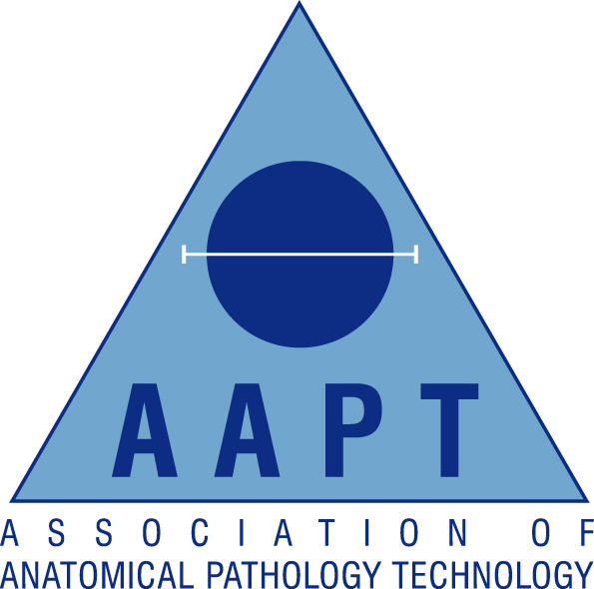

South East Regional AAPT Network

Lecture evening

Friday 8th June 2018
Organised by Lydia Judge-Kronis & Debbie James
Return form to: deborah.james1@nhs.net or fax 01323 413830
Location: Post Graduate Room
Eastbourne District General Hospital
Kings Drive
Eastbourne, BN21 2UD
18.00-18.30 Registration
18.30-20.30 Suturing & Cosmetic Application – Ben Whitworth
Discussion & Workshop covering the presentation of the deceased for viewing and ID - featuring some hand on practical training with suturing and cosmetic application.
19.15-19.30 Refreshments
20.30-21.00 Collection of CPD Certificates and Networking

AAPT Membership Number:

Non-Member (please tick)

Personal Details:
Surname |  | Title:  (Mr/Mrs/Miss/Ms)
Forenames

Contact Details:
Contact Address

Town/City |  | Postcode
Email |  | Contact Tel

