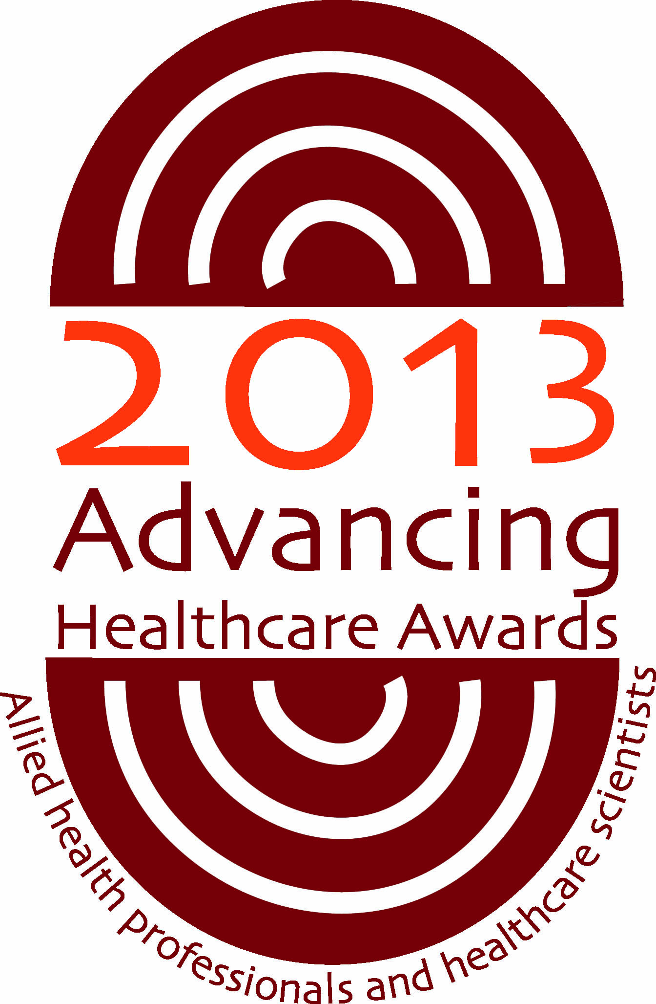
ADVANCING HEALTHCARE AWARDS 2013

For immediate release:
Advancing Healthcare Awards shortlist announced
The shortlist for the 2013 Advancing Healthcare Awards, has been announced and features allied health professionals and healthcare scientists from across the UK.
Across the eight categories in the programme we are delighted to be recognising innovative and inspiring patient care, from professional and specialists groups whose achievements so often go unnoticed.

Category 1 – The Chief Scientific Officer’s Award for Research into action: the successful implementation of research findings to the benefit of patients
Sponsored by NHS, England

Kimberly Gilmour (Clinical Scientist), Suzanne Drury (Clinical Scientist), Chiara Bacchelli, Lucy Jenkins, H. Bobby Gaspar, Catherine M. Cale, Nicholas J. Lench, Shahnaz Bibi, Sam Loughlin
Great Ormond Street Hospital for Children NHS Trust
Identifying the cause of severe combined immunodeficiency (SCID): Development of a next generation sequencing (NGS) approach for routine diagnostics

Penny Hogg (Development Officer)
NHS Blood and Transplant
Development of a Decellularised Dermis Graft

Joanna Fuller (Clinical Vascular Scientist), Helena Edlin (Vascular Laboratory Manager)
Central Manchester University Hospitals Foundation Trust
Improving patency rates of lower limb bypass grafts.

Category 2 - Outstanding achievement by an AHP or healthcare science support worker or technician
Sponsored by The Patients’ Association

James Routen (Deputy Sports and Leisure Coordinator)
Nottinghamshire Healthcare NHS Trust

Natasha Farleigh (Assistant Project Manager), Lucy Gough (Assistant Dietetic Practitioner)
South Essex Partnership University NHS Foundation Trust

Karen Lloyd (Senior Technician Ward Based Services), Hafsa Sattar (Pharmacist),
Pennine Acute Hospitals NHS Trust
Pharmacy Ward Based Prescription Dispensing Service

Category 3 – Supporting the future workforce
Sponsored by NHS Employers

Judy Goodfellow (Specialist Speech and Language Therapist), Bernie Brophy Arnott (Speech & Language Therapy Manager), Susan Munro (Specialist Speech and Language Therapist), Karin Taylor (Specialist Speech and Language Therapist), Kirsty Forde (Speech and Language Therapist), Natasha Rough (Speech and Language Therapist), Nicky Stewart (Support Worker), Tracey Hudson (Support Worker), Karen McCabe (Admin & Clerical) and Carole Sutherland (Speech and Language Therapy Manager)
NHS Tayside
Opening Horizons - Supporting Student Placements in Learning Disability and Mental Health

Julie Chapman (Practice Education Facilitator), Laura Stanley (Occupational Therapist), Complex Discharge and rehabilitation services staff
Central Manchester University Hospitals Foundation Trust
Interprofessional Learning in Practice

Alexia Quin (Director), Sarah Hadley (Professional Lead Music Therapy)
Music as Therapy International
Interactive Music-Making for Practice: Working with the Under 5s

Category 4 - AHP and Healthcare Scientists: leading together on health
Sponsored by Unite the Union

Russell Hart (Radiotherapy Services Manager), Keith Langmack ( Head of Radiotherapy Physics), Allison Wallace, Deborah Launders, Stephen West, Lindsay Brearley, Judy Christian
Angela Mckenna, Liz Harron, Anna Mason, Hugh Brown
Nottingham University Hospitals NHS Trust
Intensity Modulated Radiotherapy in Nottingham

Phillipa Burns (Biomedical Scientist), Stuart Allen (Principle Cardiac Physiologist), Cardiac Team: Dr Fozia Ahmed, Dr Ali Zaki, Dr Amir Zaidi, Microbiology Team: Bernard Wood (Laboratory Manager), Malcolm Armstrong (Deputy Laboratory Manager), Dr Ahmed Quamruddin (Consultant Microbiologist)
Central Manchester University Hospitals NHS Foundation Trust
Improved Diagnosis & Treatment of Pacemaker Pocket Infections: A patient Focused Collaboration between Microbiology & Cardiology at Central Manchester Foundation Trust (CMFT)

Vicki Howarth (Consultant Histopathologist), Emily Moore (Anatomical Pathology Technician Team Leader), Mr Anthony Watts, Miss Emma Salcidos, Mrs Tracey Unsworth, Miss Rebecca Hales, Miss Sara Wilson, Miss Jennifer Linde, Dr David Shelton, Dr Amani Brown
Stockport NHS Foundation Trust
Redesigning the delivery model for mortuary services

Category 5 – Improving quality: measuring and demonstrating impact
Sponsored by The Scottish Government

Roy Craven (Diagnostic Radiographer)
Central Manchester University Hospitals NHS Foundation Trust
Improving the Hysterosalpingogram Clinic

Emma Cork (Stroke Therapy Service Lead), Terry Gorst (Specialist Physiotherapist), Julie Cox
Kat Quick, Fran Davies, Lorna Boerboom, Claire Harris, Louise Holmes, Rachel Stephens, Nicola Mathers, Claire Hakin, Ruth Stamp, Diana Stephens, Debbie Groves, Suzie Maddocks, Liz Warner, Janet Finn, Kirsty Thomas, Jemma Sampson, Andy Burgess, Mervyn Dent, Tim Ayres, Mika Clayton, Helen Cooke
Northern Devon Healthcare Trust
Meeting the Rural Challenge-Northern Devon Stroke Early Supported Discharge (ESD) and VISTA Service

Jean McQueen (AHP Consultant), Elaine Hunter (AHP Advisor Mental Health), Lisa Greer (AHP Lead Vocational Rehabilitation), AHP Leads Group Forensic Mental Health
Forensic Network & Alzheimers Scotland
Towards Work in Forensic Mental Health

Christine Owen (Head Occupational Therapist)
St Johns Hospital
Developing a service pathway for children with Developmental Co-ordination disorder (DCD) based on current best practice guidance

Category 6 – Rethinking the patient care pathway
Sponsored by Department of Health, Social Services and Public Health Northern Ireland

Joanne Horton (Occupational Therapist), Wendy Wilkinson (Macmillan APOT)
Abertawe Bro Morgannwg University Health Board
Cancer Rehabilitation: Patient Choice!

Joy Whelan (Community Dietitian), Anne Gormley (Head of Nutritian), Dr William Dickey (Consultant Gastroenterologist)
Western Health and Social Care Trust
Extended Scope Practitioner (ESP) Led Coeliac Clinic

Louise Baker (Team Lead Physiotherapist), Sallyann Smith (Physiotherapy Neuro Pathway Lead), Sandra Jury (Specialist PD Nurse), Jane Cameron (Specialist MS Nurse), Amanda Conroy (Team Lead Speech and language therapist), Pam Bailey (Senior Physiotherapist), Maria Rowsell (Physiotherapy Technician)
Solent NHS Trust
Community Neurology Service (CNS) Solent NHS Trust

Category 7 - Rising Star award
Sponsored by GateHouse
Nominees

Emma Ralph (Occupational Therapist)
Cwm Taf Health board

Katharine Hodgkinson (Occupational Therapist)
NHS Fife

Ankia Meiring (Clinical Lead – Ultrasound)
InHealth

Emma Key-Yeomans (Radiogapher)
Norfolk & Norwich University Hospitals NHS Trust

Ashfaq Gilkar (Applications System Manager)
West Middlesex University Hospital NHS Trust

Jordan Hepburn (Band 5 Rotational Physiotherapist)
NHS Tayside

Arlene Walker (Clinical Specialist Physiotherapist)
NHS Ayrshire and Arran

John Smith (Specialist Orthotist)
NHS Forth Valley

Rebecca Spray ( Band 5 Occupational Therapist)
Derbyshire Community Health Services NHS Trust

Angela Howard (Occupational Therapist)
NHS Fife

Category 8 – Into the limelight
Sponsored by Caboo Design

Paul Dunning (Clinical Lead)
Abertawe Bro Morgannwg University Health Board
Wellbeing through Work

Jan Vickery (Lead Physiotherapist), Nicola Baldwin (Project Manager), Rebecca Robinson (Senior Marketing Manager)
AXA PPP healthcare - Health Services
The truth about back pain

Joanne Roberts (Deputy Head of Podiatry)
Betsi Cadwaladr University Health
Transforming Community Podiatry across Wrexham

Ends

About Advancing Healthcare Awards
The Advancing Healthcare Awards, in their seventh year, are UK-wide awards for allied health professionals and healthcare scientists. They are supported by the four UK government health departments, the AHP Federation, the Federation for Healthcare Science, Unite the Union, NHS Employers, The Patients’ Association, GateHouse learning and development, Caboo Design and many of the individual membership organisations and professional bodies. It is the only awards programme which covers all these professional and specialist groups whose contribution to the patient’s recovery is so often overlooked.

Created and owned by Chamberlain Dunn, the awards rely on sponsorship and the support given by a wide range of organisations and healthcare professionals during the promotion and judging process. The programme culminates with a celebration lunch with guest speakers, at which the winners are announced and receive their certificate, trophy and any additional prizes.

All the participating organisations promote the awards and the winning entries through their networks and an Impact report is compiled demonstrating the coverage that winners and runners-up have achieved.

Twitter @AHAwards
Website: www.ahpandhsawards.co.uk
For any further information, Linnet Griffin on +44 (0) 208 334 4500.

