A ‘How to’ Guide on Reflection

Contents

 | Page
Introduction | 3
Gibbs’ Reflective Cycle | 4
Kolb Experiential Learning Cycle | 7
Schön Model of Reflection | 8
Useful Phrases for Use in Reflective Writing | 9
Bibliography | 11

Introduction
Reflection is crucial part of all Institute of Biomedical Science (IBMS) qualifications, and in the Continuing Professional Development (CPD) required to maintain Health and Care Professions Council (HCPC) registration. Reflection is an integral part of completing both the registration and specialist portfolios. When completing the IBMS Diploma of Expert Practice (DEP), Higher Specialist Diploma (HSD) or Advanced Specialist Diploma (ASD), reflective skills play a key role in the case studies that need to be submitted as part of the portfolio requirements. The HSD portfolio also requires reflection on the oral presentation delivered by the candidate and the inclusion of a reflective piece of writing that draws together the learning that has taken place while completing the portfolio.

As practicing biomedical scientists, reflection is something that you do every day, even if only unconsciously. You may think about an event or situation, how you felt and what you might do differently next time. You might not, however, normally write this down (unless you keep a diary) and instead these feelings, thoughts and your consequential actions emerge over time as learning experiences that can inform your practice. It is clear from the reflection evidence that has been submitted in some portfolios that some people struggle with trying to write in a reflective manner and yet reflection, when done carefully, is a valuable skill and core component of the learning experience.

Reflective writing is a means of formalising the thoughts and situations that have helped you to progress – and is much more than a simple description of an event. It is instead an exploration and explanation of what happened. It can be very difficult to reflect when you are caught up in an event but, by standing back shortly afterwards and reviewing what happened and thinking carefully about what it meant for you and your ongoing development and progression, reflection can help you improve your own and others’ professional practice. It is best not to leave it too long to undertake any reflection as your thoughts on what happened will change over time.

Reflective writing is different to other forms of academic writing as it requires much more subjective and personal consideration. As a result, it requires a different set of skills than those required to write formal scientific statements or essays and consequentially some people find it more challenging.

It is important to follow any specific guidance on the type of reflection that you are expected to do for any IBMS qualification but whatever that guidance states the key aspects of the reflective cycle remain the same. A common framework is the Gibbs’ Reflective Cycle.

Gibbs’ Reflective Cycle
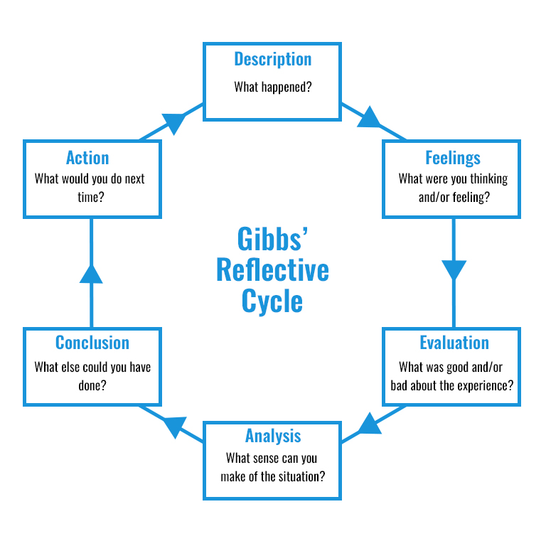
Figure 1: Gibbs’ Reflective Cycle (Source: Gibbs G., (1988) cited in University of Edinburgh (2019))

Stages of the Gibbs’ Reflective Cycle
Gibbs’ model of reflection is about ‘learning by doing’ and has six stages. The first three stages (description, feelings and evaluation) are about what happened. The final three stages (analysis, conclusion and action) are about understanding and making sense of the situation and how you can improve. The cycle encourages an individual to think systematically about their experiences during the event(s), situation(s) or activity (activities) being reflected upon.

Description
What happened or what is being examined? This should be a concise, factual account of the activity, event or situation. It is important to keep in mind that there may be a word limit to the reflective piece - even if there isn’t you will not be able to describe everything that happened. Instead you should provide only the relevant details. You are attempting to put the reader (which could be an examiner) in the picture so you need to carefully select what illustrates your point(s) most succinctly and reflect on those aspects of the event.

Feelings
You might find this part of the reflection particularly difficult to do but you should identify and examine your actions and your feelings (or thoughts, instincts, inclinations) at the time. This part of the cycle is about unpicking your personal responses that may have seemed obvious at the time. How can you explain your feelings? What was affecting them? What do you think about it afterwards?

It is important, however difficult, to try to be balanced in your judgement but also honest as doing so will make it easier to implement strategies to overcome these barriers. When you are explaining your feelings about the event, situation, case etc, you should try not to come across as still being in the grip of these feelings however strong they may have been at the time of the event.

As reflective writing is much more personal than other forms of writing such as essays and case studies, it is perfectly reasonable to write reflectively in the first person and to use such words as ‘I’, ‘for me’, ‘us’, ‘my’, ‘our’ and ‘we’ to explain your feelings and actions from the time of the event. At the same time the reflection should be calm, thoughtful and professional in tone rather than chatty and conversational.

Evaluation
You will get a lot more out of reflection if you are honest about the things that didn’t, in addition to what did, go according to plan. Successful reflective writing involves an analysis that identifies both strengths and weaknesses as well as errors or failures. In this part of the cycle you are looking at your decisions of judgement that you made at the time of the event and about how things were going. Was it positive or negative?

You may find it hard or uncomfortable if you have handled a situation incorrectly or not to your best abilities. A good piece of reflective writing will, however, involve revealing your anxieties, errors, mistakes, disappointments or failures as well as your strengths and successes in order to help you improve in the future.

Negative experiences are often the ones that help you develop the most. If you can demonstrate an understanding of the possible reasons for anything that did not go as well as you expected, analyse why you responded in the way you did and explain what you learnt or now understand as a result of the reflection this can help you respond in a more appropriate way in the future.

You may, in your reflection, also be talking about other people. If you do so, make sure you concentrate on their behaviour (i.e. what they did or did not do) rather than their feelings as you are not in the position to know what they felt.

Analysis
In this part of the cycle you are looking to make sense of what happened in order to extract meaning from it. It is not uncommon for this phase to be undertaken alongside the evaluation phase. Think about things that may have helped or hindered the situation. For example, you may have felt that the Standard Operating Procedure (SOP) or local guideline document(s) were vague, unclear or open to misinterpretation.

Conclusion
In this part of the cycle you are summarising the key thing(s) that have been learnt through this reflection. What else could you have done? You could explain what you would do differently or how you would react next time in a similar or related situation. You may identify new knowledge and the skills that you need to develop for this to happen and the training which you require to further improve your practice in the future. This part of the cycle should be forward thinking.

Action
This is the practical section, and it is interlinked with the previous stage. How can you prepare for the situation? What needs to be in place and what resources do you need? How are you planning to improve by building on your strengths and developing and implementing mechanisms to address your weaknesses? This will help to show what it means for you in ongoing development as a practicing biomedical scientist.

Remembering the Steps in the Reflective Writing Process
As an article published on the IBMS website in 2018 explained one way of remembering the basics of writing reflectively is to use the acronym ‘STEAM’ like so:
Situation: What happened?

Thoughts: What were you thinking/feeling?

Evaluation: What was good or about it?

Analysis: What relevance did have to you/your practice?

Meaning: What changes will you make/conclusions have you drawn?

This acronym effectively covers the different stages of the Gibbs’ Reflective Cycle.
Other Models of Reflective Learning
There are other models of how to undertake reflection such as the Kolb Experiential Learning Cycle and the Schon Model of Reflection.

Kolb Experiential Learning Cycle
Kolb thought that learning styles were continuous and cyclical. In this model, effective learning is seen as a process where a learner progresses through a cycle of four stages and that people learn by building on the knowledge that they already have through completing tasks. Kolb’s theory suggests that every day we learn from our experiences and that reflection plays an integral part of that learning.
Abstract Conceptualisation
(concluding / learning
from the experience)
Reflective Observation
(reviewing / reflecting
on the experience)
Concrete Experience
(doing / having an experience)

Active Experimentation (planning / trying out
what you have learnt)

Figure 2: Kolb Experiential Learning Cycle (Source Kolb D., (1984) cited in Lifelong Learning with OT (2016))

In the first stage of Kolb’s Experiential Learning Cycle the individual experiences a situation or event (concrete experience) after which they reflect upon it to draw out what they thought, felt and/or learnt (reflective observation). In this process it is particularly important for the individual to draw out any inconsistencies between their understanding and the actual experience.

Once the individual has reflected (abstract conceptualisation) this gives rise to a new idea or more likely a modification of an existing idea or concept which the individual then applies to see what happens as a result (active experimentation). This approach is often taken when learning practical / laboratory-based skills, so you may recognise this cycle without having known the theory behind it.

Schön Model of Reflection
The Schön model distinguishes between reflection ‘in-action’ and ‘on-action’.

Reflection ‘in-action’ (or ‘action present’) happens at the time of the event and is about practicing critically. It works on getting to the bottom of what is happening and the experiencer’s processes, decision-making and feelings at the time of the event. So, for example, a biomedical scientist who is undertaking a cut-up on a specimen is making decisions about the appropriateness of the process that they are using and judging the success of the procedure as they undertake the process.

Reflection ‘on-action’ happens after the activity has taken place. It works at going over the event and considering new information or theoretical perspectives available in conjunction with the experiencer’s processing, feelings and actions. At this point an individual can think about what they (and, if appropriate, others) did. You can make a judgement on how successful you were and whether, if you had changed what you did, there could have been a different result or set of outcomes.

- Considering the situation / the experience itself
- Thinking about it during the event
- Deciding how to act
- Acting immediately
Reflection in action
Reflecting at the time the event is happening

- Re-considering the situation or experience
- Information gained and/or theoretical perspectives learnt inform reflector’s experience and are used to process feelings and actions
- Thinking about what needs to change in the future
Reflection on action
Reflecting on something that has happened after the event

Figure 3: Schön Model of Reflection (Adapted from: Schon D. (1983))

Useful Phrases for Use in Reflective Writing
Many people find starter phrases useful when writing a piece of reflection. The following is a list of phrases that may help you write about your experiences. You do not need to use a word in each column when constructing your reflections or feel constrained by them. They are only suggestions. Ultimately, the reflection you write will be personal to you.
These phrases will help you demonstrate how you interpreted the issue, event, case, situation etc. being discussed:
 | meaningful | issue(s) | began
 | important | idea(s) | happened when
For me, the (most) | significant | experience(s) | resulted from
(main) | relevant | event(s) | arose from / when
 | useful | element(s) | was (were)
 | interesting  crucial  key | aspect(s)  activity(ies)  point(s)

These phrases will help you explain your understanding:
At the time |  | thought (did not think)
At first |  | felt (did not feel) |  | that
Initially |  | noticed (did not notice) |  | why
Later | I | questioned (did not question) |  | how
As a result |  | realised (did not realise) |  | if
Subsequently |  | knew (did not know)
Previously |  | was aware (was not aware)

 | might (have) be (been) | because of
This | is perhaps | due to
 | could be | as a result of
 | is probably | explained by
 | is partly  is solely | related

These phrases will help you tell how it has enabled you to develop your practice and understanding:
 | read(ing) |  | feel
 | applied/applying |  | think
Having | discussed/discussing | I (now) | realise
As a result of | analysed |  | question
 | reviewed/ reviewing |  | believe
 | learned |  | know
 | spoken/speaking with |  | understand
 | liaised with |  | wonder if
reflected/reflecting on
experienced
resolved
These phrases will help you tell the effect it will have / did have on your future practice and understanding:

 | slightly | develop(ed) |  | skills in
I have | significantly | improve(d) | my | knowledge of
I will | increasingly | increase(d) |  | ability to
 | look to | decrease(d) |  | reliance on
 | aim to  attempt(ed) to | enrich(ed)  review(ed) |  | understanding of  competency  interaction(s) with

This skill (These skills) is essential
This understanding could be important to me because…
This knowledge will be useful
This experience has been vital
These experiences

Because I did not
As I have not yet I will now need to
am not yet sure I had to firstly
am not yet certain
was unable to (without)

Figure 4: Phrases for use in reflective writing
Adapted from: Hampton M (n.d.) Reflective Writing: A basic introduction. Department of Curriculum and Quality Enhancement. University of Portsmouth

Other Tips on Reflective Writing
Although reflection is a more personalised style of writing, it is important to always remain professional and don’t allow cynicism to come through. If you are going to use abbreviations make sure you write them in full the first time you use them in each piece of reflection. Do not use text speak and remember to reserve the normal rules of spelling and grammar. Often you will be working with a tight word limit so keep your sentences to the point and do not ramble.
Bibliography
Hampton, M (n.d.) Reflective Writing: A basic introduction. Department of Curriculum and Quality Enhancement. University of Portsmouth
Available from: http://www2.port.ac.uk/media/contacts-and-departments/student-support-services/ask/downloads/Reflective-writing---a-basic-intro.pdf [Date of Access: 15 July 2020]

Institute of Biomedical Science (2018) CPD – Reflective Practice Made Easy
Available from: https:www.ibms.org/resources/news/cpd—reflective-practice-made-easy/ [Date of Access: 19 October 2020]

Lifelong Learning with OT (2016) Guides to Models of Reflection – When and why should you use different ones?
Available from:
https://lifelonglearningwithot.wordpress.com/2016/05/02/different-models-of-reflection-using-them-to-help-me-reflect/ [Date of Access: 13 July 2020]

Lovie, R. (2019) How To…Reflect. The Biomedical Scientist. 63 (12)

McLeod S. (2017) Kolb’s Learning Styles and Experiential Learning Cycle
Available from: https://www.simplypsychology.org/learning-kolb.html [Date of Access: 13 July 2020]

Mulder, P. (2018). Gibbs Reflective Cycle by Graham Gibbs.
Available from: https://www.toolshero.com/management/gibbs-reflective-cycle-graham-gibbs/ [Date of Access: 15 July 2020]

University of Edinburgh (2019). Gibbs’ Reflective Cycle.
Available from: https://www.ed.ac.uk/reflection/reflectors-toolkit/reflecting-on-experience/gibbs-reflective-cycle [Date of Access: 27 July 2020]

Ward, C. (2017) Looking in the Mirror: Reflective Writing. The Biomedical Scientist. 61(10) 46.

About this document

Document title: A ‘How to’ Guide on Reflection

Produced by: Education and Professional Standards Committee

Contact: Education Department

T: + 44 (0)20 7713 0214 E: education@ibms.org

Version: Version 1.0

Active date: January 2021

Review date: December 2022

Copyright and disclaimer

This document and its contents, including the Institute of Biomedical Science (IBMS) logo, are the property and trademarks of the Institute of Biomedical Science. The copyright on this material is owned by the IBMS (unless otherwise explicitly stated). This document, or any part of it, may not be copied, reproduced, republished, downloaded or transmitted in any way, other than for your own personal, non-commercial use. Prior written permission must be obtained from the IBMS, using the contact details above, for any other use of this material. All rights are reserved.

copyright © Institute of Biomedical Science 2020

